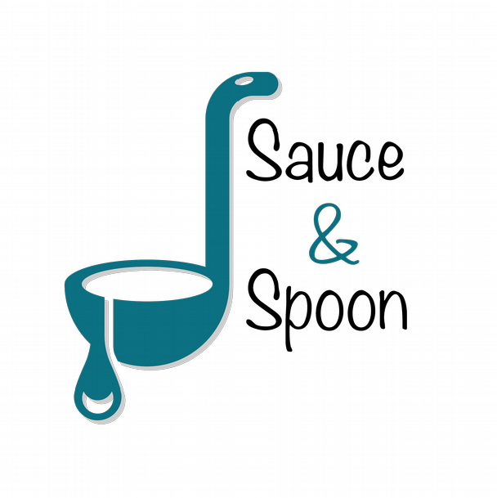

Project Charter: Table-Top Tablet Menus

DATE: [10/24/2021]

**Project Summary**

Sauce and Spoon is needed to create a more efficient process for customers

receiving their food that will lead to higher satisfaction. Sauce and Spoon would like to

help increase the sales of certain foods, decrease the turnaround time for customers,

and reduce food comps with the use of the tablets.

**Project Goals**

●

Increase product mix

●

Increase average check total to $75 by selling more appetizers and beverages

by the end of Q2, resulting in increased profits

●

Increase appetizer sales by 15%

●

Reduce table turn time by 30 minutes

●

Increase the restaurant profit by 10% by increasing the customer base by the

end of the project.

●

Reduce food waste by 25% through implementing the automated ordering

system in the bar area.

●

Decrease employee burnout and turnover rate by 25% by the end of the project

**Deliverables**

●

Providing a tablet ordering system that is compatible with the current PoS and

host system, this system to be implemented in the bar area.

●

A plan to train the staff on the new system

●

Software memberships

●

Virtual menu design and update website

●

Maintenance schedule for the new service

**Scope and Exclusion**

**In-Scope:**

●

Deliver the tablet system in the bar area of the two restaurants (north and

downtown)

●

Reduce table turn time, to increase revenue and reduce customer wait time.

●

Start the pilot at the beginning of quarter 2 in the bar areas of the downtown

and north restaurants

●

Integration with existing software.

●

Measuring the satisfaction of the kitchen staff

**Out-of-Scope:**

●

Other restaurant locations

●

Modifying company policy of confronting customers when the order is incorrect

**Benefits & Costs**

**Benefits:**

●

Add value by reducing food waste, lowering customer wait time, and reduce

incorrect orders.

●

Increase in revenue and decrease in employee workload

●

A new system that works with current software to improve service.

**Costs:**

●

Training materials and fees = $10,000

●

Hardware and software implementation across location = $30,000

●

Maintenance = $5,000

●

Update website and menu design fee = $5,000

●

Other customization fees = $550

**Appendix:**

●

Misalignment 1: Reallocate payroll to hire more kitchen staff. Action: to be

reassessed after we clean data from the pilot restaurant.

●

Misalignment 2: Change food send-back policy to reduce food waste? Action:

pushback for totally changing the policy but will revise the food waste goal to

include metrics that better capture kitchen staff’s performance

●

Misalignment 3: Define a goal for improving kitchen staff satisfaction rate?

Action: Carter will provide some specific metrics for improving the satisfaction

rate of kitchen staff as part of reducing employee turnover goal.

●

Misalignment 4: separate guest wait time reduction goal from table turn rate

reduction goal? Action: integrate these 2 goals together

[Powered by TCPDF (www.tcpdf.org](http://www.tcpdf.org/)

[)](http://www.tcpdf.org/)